Contact information
  - Name *
  - Company
  - Address *
  - Email *
  - Phone *
  - Fax

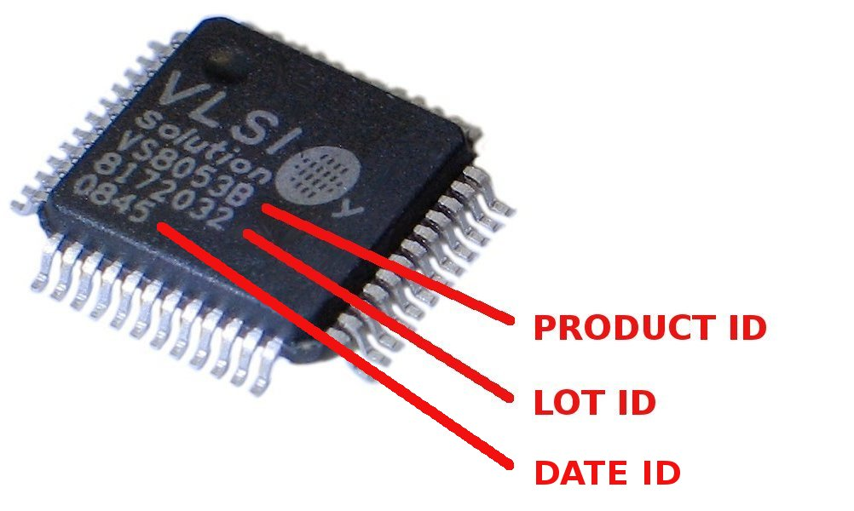
Product information
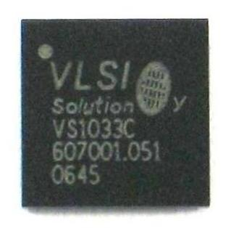BGA49
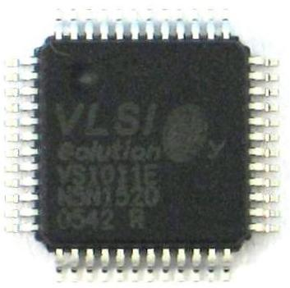LQFP48
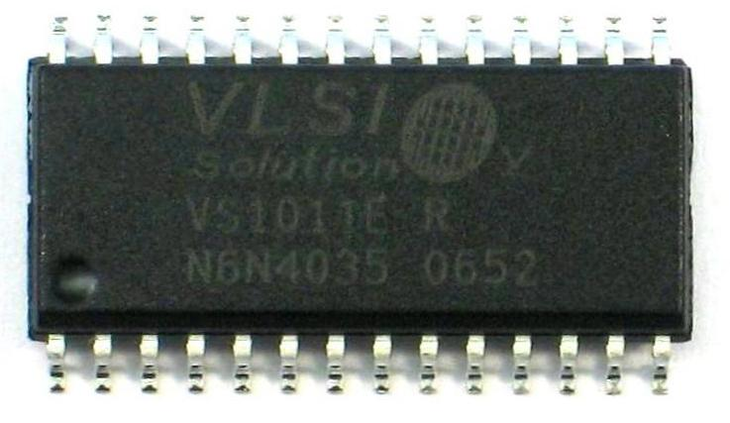SOIC28
- Product id * |  |  | VS1000D |  |  |  | VS1000E |  |  |  | VS1011E
 |  |  | VS1003B |  |  |  | VS1033C |  |  |  | VS1033D
 |  |  | VS1053B |  |  |  | VS1103B |  |  |  | VS8053B
 |  |  | Other (specify)
  - Lot id *
  - Date id *
- Package * |  | SOIC28 |  |  |  | LQFP48 |  |  |  | BGA49
 |  | Other (specify)
  - Purchased from *
  - PO number *
  - PO/Ship date *

Problem Description
- Please describe the problem clearly * | At which stage of the production was the problem found?  What was found to be wrong?  What indicates that the problem is in VLSI's Product?  How to reproduce the problem in the laboratory?  Can you share the circuit schematic around the VLSI's product for a review?

Statistics
  - What was the operating environment? (used voltages, temperature, humidity)
  - How many failing products were found? *
  - How many products were used to get the number of failing products in 4.2? *
  - How many products are potentially affected? *

RMA
- Do you want to return parts? * |  | No , I want just failure analysis (FA) |  | Yes, I want failure analysis and replacement of defected units
  - Number of products for failure analysis *
  - Number of products that are requested to replace, please give Lot ids also

Attachments
  - Number of attachments
  - Description of attachments

RMA
  - RMA number (do no fill)
  - RMA instructions from VLSI (do not fill)

Instructions
The return process has seven steps:
- Fill the RMA form.
- Send it to quality@vlsi.fi.
- Wait for an RMA number.
- You will get back the form with RMA number and instructions (Chapter 7).
- Send the (sample of) defected units to VLSI.
- Wait for 8D report.
- If 8D report has approval of material return ship all agreed units for replacement.

To initiate the warranty process please fill in the RMA form. Required fields are marked with a asterisk (*). Complete the RMA form and send it by email to quality@vlsi.fi. Note that we can not accept incomplete forms.

Approved RMA form will be returned by email together with an RMA number and RMA instructions filled. Do not send any units to VLSI without an RMA number. The RMA number is valid for 15 days. Products sent after this period need a new RMA number.

Note that VLSI is not responsible of any defects or problems caused by the delivery or improper handling of the returned material. Attach the address label on the outer delivery box. Products should be 100% reusable, so pack the products properly and handle with care. The packing for RMA should be done with the same quality as the original packing.

Proforma invoice should include the following information:
RMA number | (from Chapter 7.1)
Product id | (from Chapter 2.1)
Quantity | (from Chapter 5.3 or 7.2) pcs
Value: | 0.01 USD/pcs each, total (Quantity x 0.01) USD
Country of origin | (see Chapter “Country of Origin” on the next page)
Delivery address | VLSI Solution Oy  Hermiankatu 8 G, 2nd floor  FIN-33720 Tampere  FINLAND
Status | REJECTED MATERIAL RETURNED TO SELLER

Attach the address label on the outer delivery box. Do not write anything on the inner boxes.

Country of origin
Country of origin | South-Korea (Kr) | VS1000D, VS1000E, VS1003B, VS1103B, VS1053B, VS8053B
 | Israel (IL) | VS1011E
 | Malaysia (MY) | VS1033C, VS1033D

Transportation Costs
Companies (and distributors)
Companies (and distributors) shall pay the transportation costs of the return delivery.
VLSI Solution will pay the transportation costs of the replacement (or fixed product).

Private persons
VLSI Solution will pay the transportation costs of the return to both directions. You need to receive the RMA number and delivery instructions from VLSI Solution before the delivery.

